Project Design Document
Wanderer — A Dancing Doll Console Game
Manasa | Section C | 2025014044

1. Design Intent

What experience are you trying to create?
Wanderer is an interactive arcade-style installation that turns physical button presses into a live, multi-sensory performance. The player sits at a custom console and plays a rhythm game — matching directional arrows on an OLED display — while simultaneously watching a small dancing doll on a stage physically move its limbs in response. The two systems (game and doll) are connected wirelessly, making the player feel like a puppeteer and a rhythm-game contestant at the same time. The goal is to create an experience that is playful, surprising, and character-driven — where the physical and digital worlds react to each other in real time.

Who is it for?
Anyone who walks up to the installation — no prior knowledge of games or electronics required. The design targets a broad audience: children are drawn to the physical doll movements, older players engage with the rhythm game challenge, and technically curious people appreciate the electronics and wireless communication. The interface is intentionally physical and immediate — buttons, a visible stage, a character — rather than a screen-only experience.

What problem does it solve?
Most digital games have no physical presence in the room — the output lives entirely on a screen. Wanderer solves this by making the output tangible: a doll that visibly dances because you pressed a button. It bridges the gap between an electronic game console and a physical performance, making computing feel alive rather than abstract.

2. Inspiration & References
- Dance Dance Revolution (DDR) — directional arrow rhythm game format; the idea of matching arrows to a beat under time pressure
- Guitar Hero / Beat Saber — single-player rhythm games where physical input maps to musical timing; visual language of falling notes toward a hit line
- Animatronic figures at theme parks (e.g., Disney Audio-Animatronics) — the idea that a character can physically express motion in response to input
- Old-school arcade cabinets — physical console design with exposed buttons and a dedicated screen, rather than a smartphone interface
- Tamagotchi / virtual pet toys — the idea of a character that reacts and performs based on what the player does
What was learned from these references:
- Rhythm games need a clear hit-line and falling indicator — adapted directly into the 4-lane OLED layout
- Physical output (the doll moving) adds emotional engagement that screen-only output cannot replicate
- Simplicity of input (4 directional buttons) allows immediate play without a tutorial

3. User Journey
- User approaches the stage — sees a decorated doll on a lit stage and a custom console sitting in front of it
- User notices the OLED displays on the console — one shows 'PRESS START', the other shows an idle character animation
- User presses the large START button — the game OLED fills with 4 lanes and arrows begin scrolling downward
- User presses a directional button (right/down/up/left) to match an arrow reaching the hit line
- On a hit: combo counter increments; the animation OLED shows the corresponding character pose (up/down/left/right)
- On a miss: error counter increments; the animation OLED shows an 'error' expression on the character
- Simultaneously: the stage ESP32 receives the button command wirelessly and the corresponding doll limb moves briefly then returns to neutral
- User plays through all 50 notes, watching both their score and the doll react in real time
- User presses STOP at any point to reset and hand the console to the next player

4. Success Criteria

Functional
- Directional button press registers and triggers correct lane hit within ±250ms timing window
- Both OLED displays update within one 5ms game loop cycle — no perceptible lag
- ESP-NOW wireless command delivered from console ESP32 to stage ESP32 in <100ms
- Servo moves to target position and returns to neutral within 0.3 seconds of receiving command
- START button initialises a fresh game with reset score; STOP button cleanly halts game at any point
- All 50 generated notes appear and pass through the game display without rendering errors

User Experience
- A first-time player can understand the directional input mechanic within 30 seconds without explanation
- The connection between pressing a button and the doll moving is immediately obvious — player feels in control
- Both screens are readable from a standing position at approximately 30–50cm distance

Reliability
- System operates continuously for at least 10 minutes without crash or reset
- Debounce logic prevents false inputs under rapid repeated pressing
- Wiring and connections remain stable throughout a demo session

5. System Overview
Wanderer consists of two physically separate ESP32 systems that communicate wirelessly:
Console Unit (ESP32 #1):
- SH1106 OLED (I2C0, SCL=18, SDA=19) — runs the rhythm game display
- SSD1306 OLED (I2C1, SCL=22, SDA=23) — displays character animation frames
- 6 push buttons with pull-up resistors — 4 directional (R/D/U/L), START, STOP
- MicroPython game loop: note generation, arrow rendering, hit detection, score tracking, animation state machine
- ESP-NOW sender: transmits directional commands wirelessly to the stage unit
Stage Unit (ESP32 #2):
- PCA9685 PWM driver (I2C, addr 0x40) — controls 4 servo motors on channels 0, 3, 4, 6
- 4 servo motors — physically attached to the doll's limbs (up/down/left/right joints)
- ESP-NOW receiver: decodes incoming direction commands and triggers corresponding servo movement
- reset_all() function holds all servos at neutral angle (65°) between movements
- Powered by two 18650 Li-ion cells through a power module

6. High-Level Block Diagram
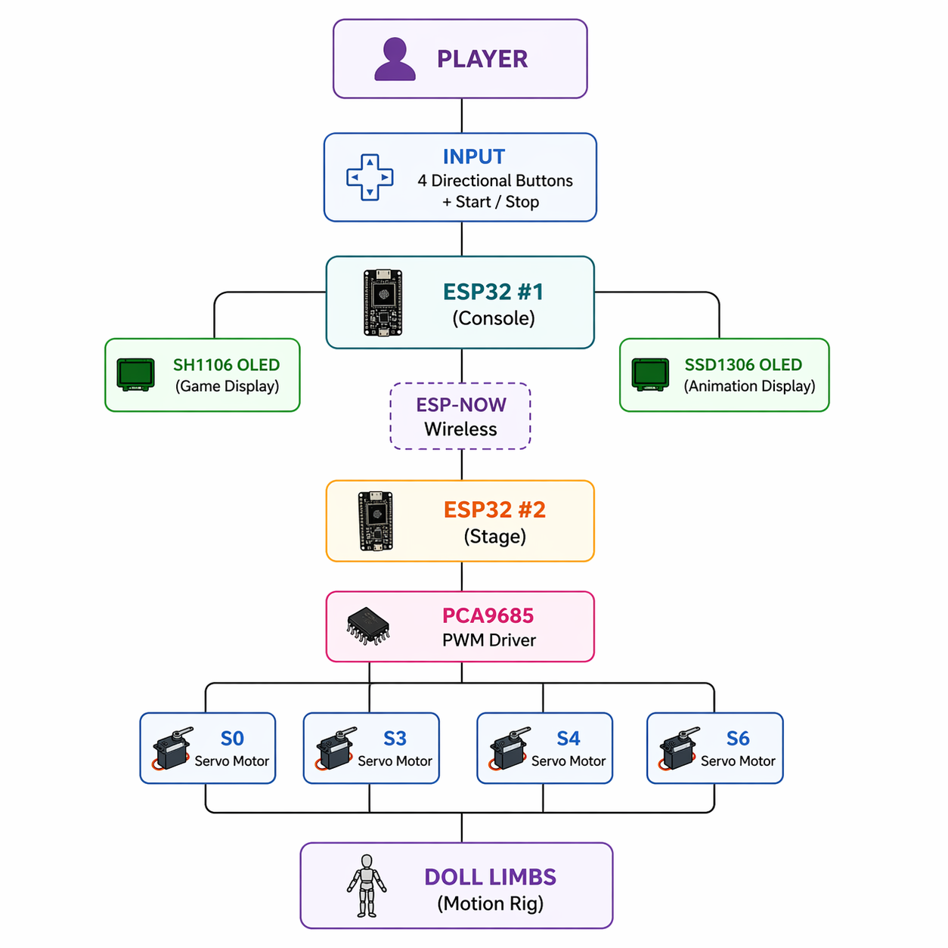

7. Input / Output Mapping
Input | Process | Output
RIGHT button (GPIO 27) pressed | Hit detection checks if note in lane 0 is within ±250ms; animation state → 'right'; ESP-NOW sends 'RIGHT' | Combo increments; character shows right pose; servo 0 (right arm) moves briefly
DOWN button (GPIO 14) pressed | Hit detection checks lane 1; animation state → 'down'; ESP-NOW sends 'DOWN' | Combo increments; character shows down pose; servo 3 (right leg) moves briefly
UP button (GPIO 32) pressed | Hit detection checks lane 2; animation state → 'up'; ESP-NOW sends 'UP' | Combo increments; character shows up pose; servo 4 (left arm) moves briefly
LEFT button (GPIO 13) pressed | Hit detection checks lane 3; animation state → 'left'; ESP-NOW sends 'LEFT' | Combo increments; character shows left pose; servo 6 (left leg) moves briefly
Note passes hit line un-pressed (dist < -250ms) | Note marked 'passed'; error counter increments; animation state → 'error' | Error counter increments on SH1106; character shows error expression on SSD1306
START button (GPIO 25) pressed | Game state set to running=True; score reset; generate_notes() called; timer started | 'START' message briefly on SH1106; game loop begins
STOP button (GPIO 26) pressed | Game state set to running=False; displays cleared | 'STOPPED' message on SH1106; system returns to idle
1 second of no button press | Animation timer expires (now - last_hit_time > 1000ms) | Character animation returns to idle frame on SSD1306

8. Sketches & Concepts — Iterations

Iteration 1 — Early Concept
Initial idea was a simple animatronic lightbox with servo-driven limbs controlled by a single ESP32 and three push buttons. No game component existed at this stage — the buttons just toggled servo positions. The doll was a rough cardboard cutout used to validate servo torque and linkage positioning.

Iteration 2 — Adding the Game
The rhythm game concept was introduced to give the console purposeful, timed interaction rather than free-form button pressing. A single OLED was first tested with a basic falling-block prototype to validate the note-scrolling formula (y = HIT_LINE_Y - dist/30). The animation display was added as a second layer to give the player visual character feedback beyond just score counters.

Iteration 3 — Wireless Split
The system was split into two ESP32 units connected via ESP-NOW to allow the console and stage to be physically separate. This introduced the sender/receiver code architecture. The PCA9685 servo driver was added to handle 4 simultaneous servos cleanly from a single I2C bus.

Iteration 4 — Final Hardware Build
Stage was laser cut from MDF. Doll was re-fabricated with cleaner servo linkages. Console was 3D printed and wired on a breadboard inside. Two 18650 Li-ion cells provided portable power. DXF files were created for the doll's base joints.

9. Final System Architecture
Console ESP32 Pin Map:
Component | Pin | Bus / Config
SH1106 OLED (game) | SCL = 18 / SDA = 19 | I2C0
SSD1306 OLED (anim) | SCL = 22 / SDA = 23 | I2C1
RIGHT button | GPIO 27 | PULL_UP, active low
DOWN button | GPIO 14 | PULL_UP, active low
UP button | GPIO 32 | PULL_UP, active low
LEFT button | GPIO 13 | PULL_UP, active low
START button | GPIO 25 | PULL_UP, active low
STOP button | GPIO 26 | PULL_UP, active low

Stage ESP32 Pin Map:
Component | Channel / Pin | Notes
PCA9685 PWM Driver | I2C addr 0x40, SCL/SDA | Controls all 4 servos
Servo — UP (right arm) | PCA9685 Channel 0 | Neutral = 65°
Servo — DOWN (right leg) | PCA9685 Channel 3 | Neutral = 65°
Servo — LEFT (left arm) | PCA9685 Channel 4 | Neutral = 65°
Servo — RIGHT (left leg) | PCA9685 Channel 6 | Neutral = 65°
Power | 2× 18650 Li-ion cells | Through power module, 5V output

Code Files:
File | Runs On | Purpose
modified_code.py | Console ESP32 | Main game loop, dual OLED control, animation state machine, button reading, score tracking
sender_espnow.py | Console ESP32 | Reads 4 directional buttons, transmits UP/DOWN/LEFT/RIGHT via ESP-NOW
receiver_espnow.py | Stage ESP32 | Receives ESP-NOW commands, drives corresponding PCA9685 servo channel
idle.py / up.py / down.py / left.py / right.py / error.py | Console ESP32 (imported) | Bitmap data arrays for each character animation frame

